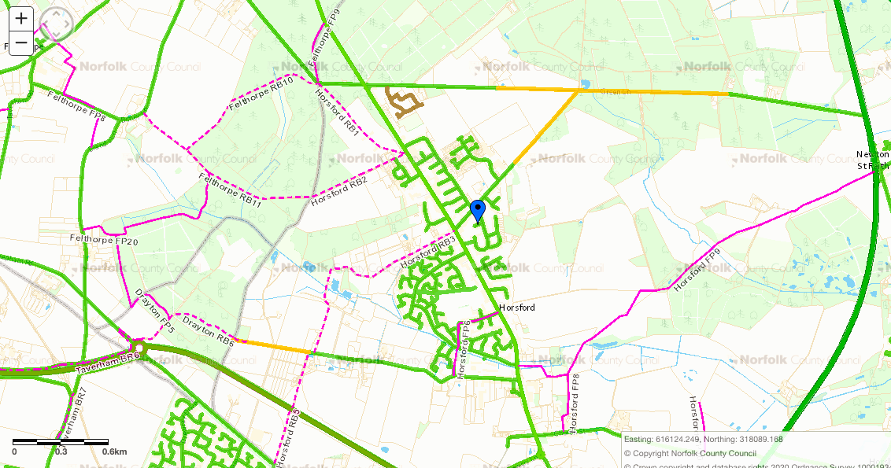

RB4 Connects Dog Ln

To Drayton RB6

School

RB1 Broadland Country Park Car Park through St Faiths Common pass the Chicken Farm to Sandy Ln

FP6 Holt Rd go down Corner Ln cross Horsbeck Way to

Dog Ln

RB3 Circular route From Holt Road down Pyehurn Ln to Dog Ln, to Holt Road

RB2 Circular Route Holt Rd down Sandy Lane pass the All Creatures to join Felthorpe footpaths

FP9 From Holt Rd opposite Horsbeck cross field to Cromer Rd

Way

RB10 from Church St to Horsford Castle

FP8 Church St connects to FP9

RB5 Dog Ln at Bell Farm you can cross NDR bridge to Reepham Road

RB7 Glebe Farm on Old Holt Rd to Brewery Lane

Horsford’s FP11 and FP12 are outside the built-up area of Horsford near to Hellesdon from Reepham Rd