- Be extraordinary  Become a Local Councillor  Parish councils make all kinds of decisions on issues that affect the local community. Probably the most common topics that parish councils get involved with are planning matters (they are statutory consultees), crime prevention, helping local groups, managing open spaces and campaigning for and delivering better services and facilities.  Local elections take place on Thursday  4th May 2023 are you willing to put yourself forward?  The last date for nominations is:  4 pm Tuesday 4th April 2023.  Nominations will be published by:  4 pm Wednesday 5th April 2023.  CAWSTON PARISH COUNCIL  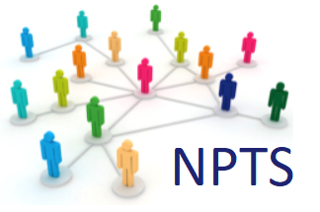 | Would you like to:  ____  Make a difference to local people’s lives?  ____  Give something back to your community?  ____  Help shape your community for the benefit of all its residents?  ____  Make Horsford a great place to live?  For more details contact:  cawstonpc@yahoo.co.uk  01603714172  www.cawston-parish-council.norfolkparishes.gov.uk

